JOB CHECK LIST ICON

The Icon known as ”JOB CHECK LIST” is a valuable tools for quality control to assure that the each process of the job is validated by a number of users. The icon can be view during the job, data collection and inquires. Reports requested by customers for ISO or general quality checks can be generated from the information obtained. In addition, the folders and fields of each folder may be deleted, added or changed to make the job checklist unique to your company.
Each job will have separate data for each operation that will be available during data collection, job costing and order inquires.

JOB FILE

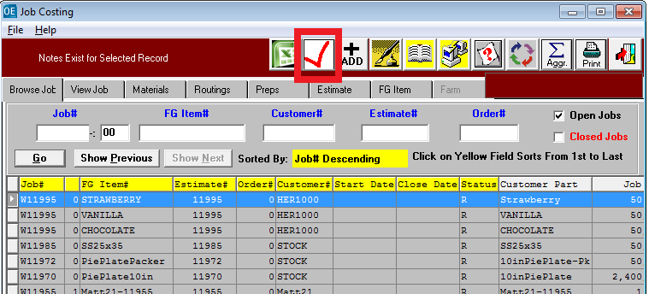

TOUCH SCREEN

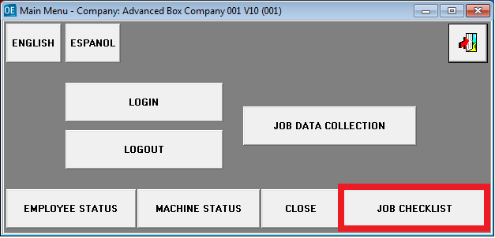
JOB CHECK LIST ICON

The ”JOB CHECK LIST” is also listed in Touch Screen Data Collection so that each machine can update their specific quality control notes and controls..

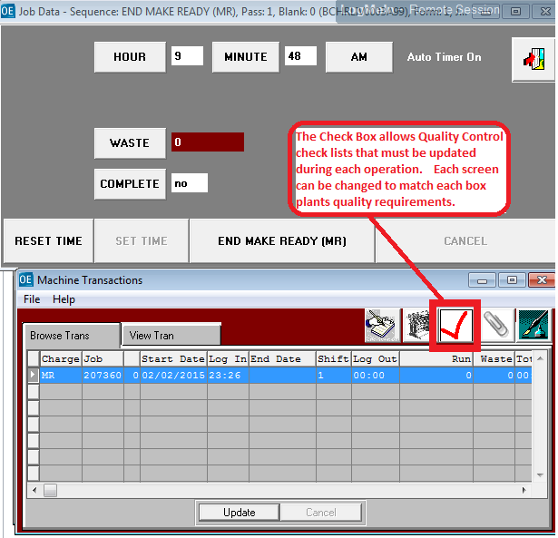
. JOB CHECK – PRE FLIGHT

The Pre Flight folder of the ”JOB CHECK LIST” icon provides is a tool to double check that the job is ready for production. The fields may be deleted, added or changed to make the job checklist unique to your company.

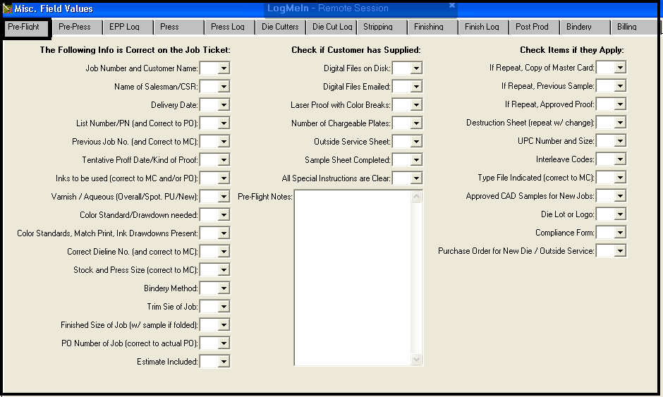

. JOB CHECK – PRE PRESS

The Pre Press folder of the ”JOB CHECK LIST” icon provides is a tool to double check that the job is ready for printing . The fields may be deleted, added or changed to make the job checklist unique to your company.

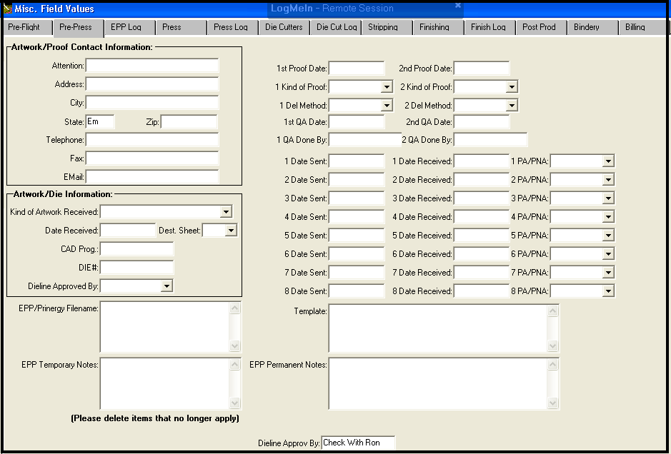

. JOB CHECK – EPP LOG

The EPP LOG folder of the ”JOB CHECK LIST” icon provides is a tool to double check that the job is ready for printing . The fields may be deleted, added or changed to make the job checklist unique to your company.

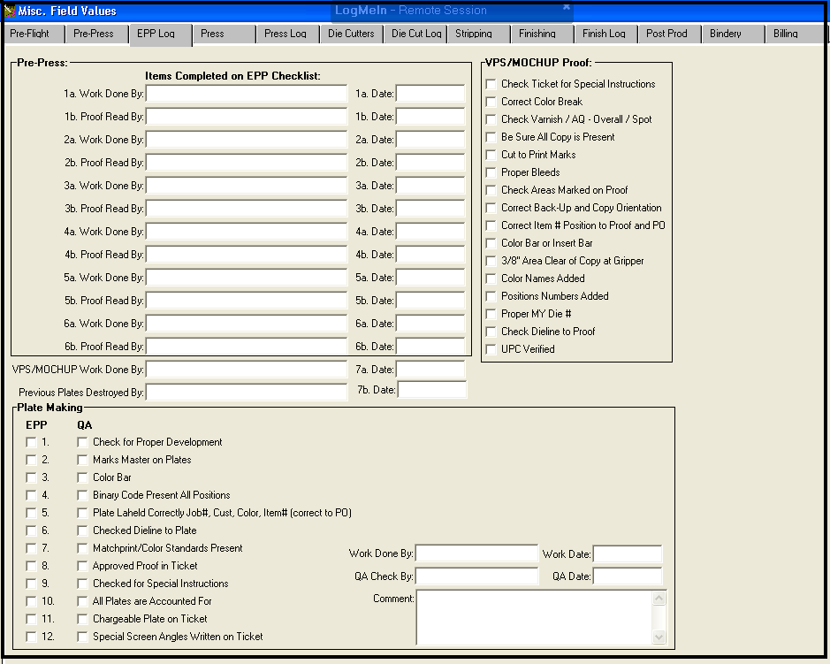

. JOB CHECK – PRESS

The PRESS folder of the ”JOB CHECK LIST” icon provides is a tool to ensure the printing process is being run with the companies process standards with date and time stamps and operator check points. The fields may be deleted, added or changed to make the job checklist unique to your company.

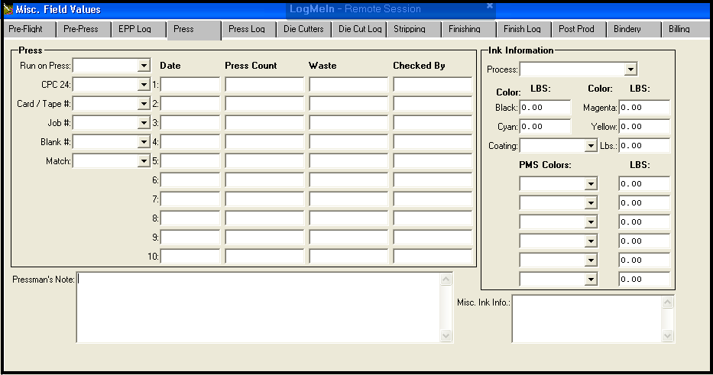

. JOB CHECK – PRESS LOG

The PRESS LOG folder of the ”JOB CHECK LIST” icon provides is a addition screed to ensure the printing process is being run with the companies process standards with date and time stamps and operator check points. The fields may be deleted, added or changed to make the job checklist unique to your company.

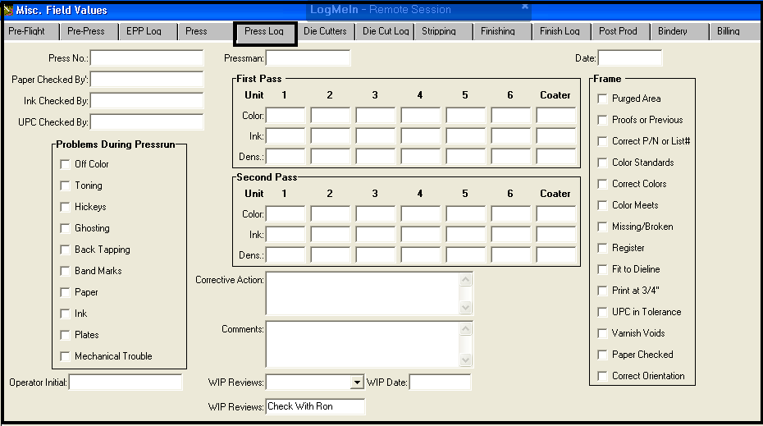

. JOB CHECK – DIE CUTTERS

The DIE CUTTERS folder of the ”JOB CHECK LIST” icon provides a check on data for the die cutting process. The fields may be deleted, added or changed to make the job checklist unique to your company.

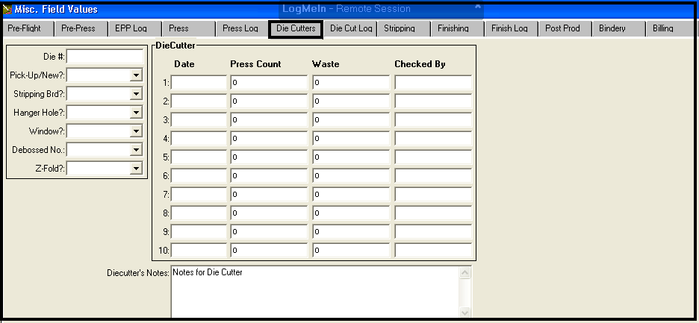

. JOB CHECK – DIE CUTTERS LOG

The DIE CUTTERS LOG folder of the ”JOB CHECK LIST” icon provides a quality check to enter data for the die cutting process with date and time stamps and operator check points. The fields may be deleted, added or changed to make the job checklist unique to your company.

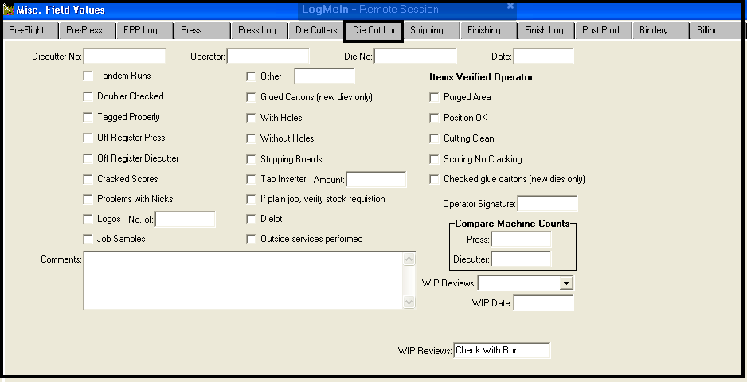

JOB CHECK – STRIPPING

The STRIPPING folder of the ”JOB CHECK LIST” icon provides a quality check to enter data for the hand stripping or auto stripping department with date and time stamps and operator check points. The fields may be deleted, added or changed to make the job checklist unique to your company.

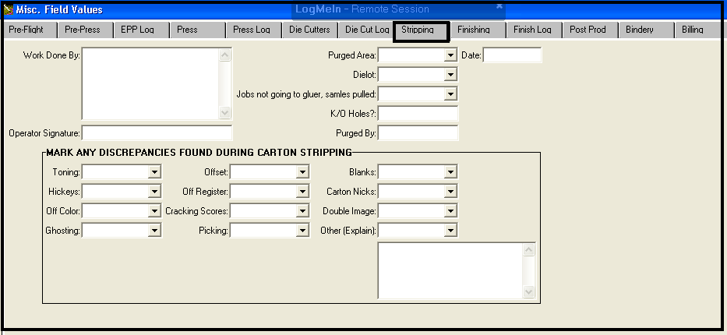

JOB CHECK – FINISHING

The FINISHING folder of the ”JOB CHECK LIST” icon provides a quality check to enter data for the finishing operations such as gluing, windowing and hand labor. Operators can enter the date, packing information and other data. The fields may be deleted, added or changed to make the job checklist unique to your company.

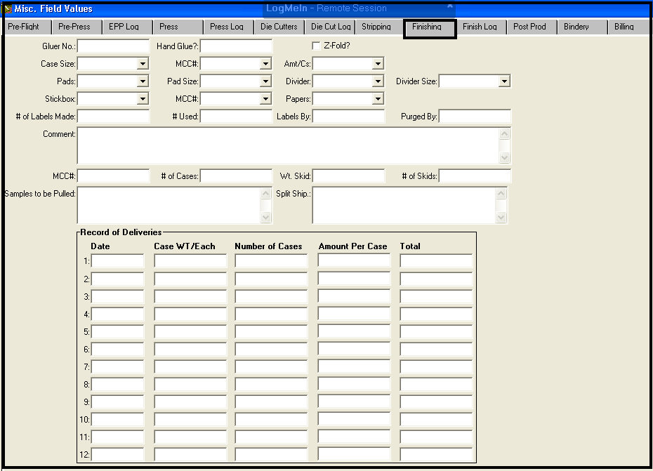

JOB CHECK – FINISHING LOG

The FINISHING LOG folder of the ”JOB CHECK LIST” icon provides a post production quality check to enter data for the finishing operations such as gluing, windowing and hand labor. Operators can enter the date, packing information and other data. The fields may be deleted, added or changed to make the job checklist unique to your company.

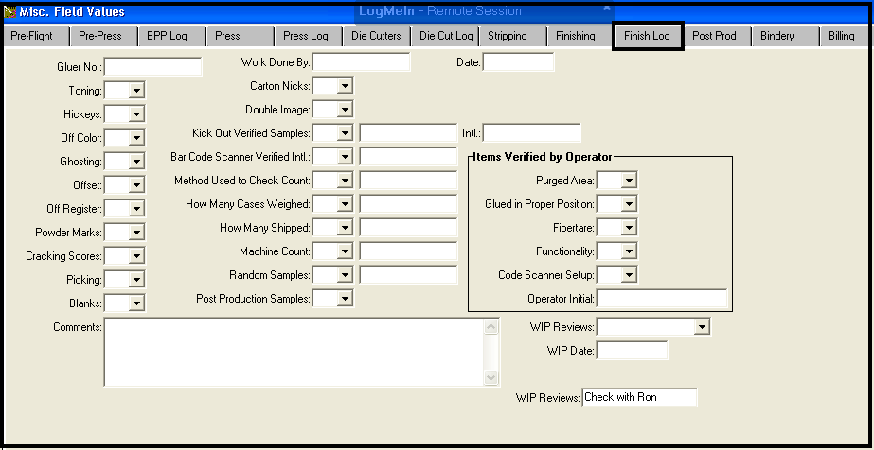

JOB CHECK – POST PRODUCTION

The POST PRODUCTION folder of the ”JOB CHECK LIST” icon provides a final post production quality check to enter data for the entire job. Operators can enter the date, packing information and other data. The fields may be deleted, added or changed to make the job checklist unique to your company.

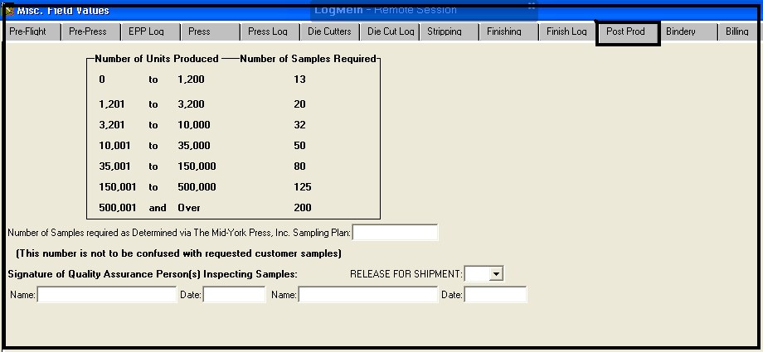

JOB CHECK – BILLING

The BILLING folder of the ”JOB CHECK LIST” icon provides a final billing check to enter data for the entire job. Operators can enter the date, packing information and other data. The fields may be deleted, added or changed to make the job checklist unique to your company.

